**MADHYA PRADESH**

**1. AAYAM GROUP**



**Our Goals:**

* To empower women by building in them a capacity to earn for their financial and social well being.
* Spark the awareness among the people towards environment and energy scenario.
* Capacity building of socio-economically weak people, handicaps and minorities.
* Building up of sustainable models of community health and rural development through people’s participation.

**Objectives:**

* To work towards the development of Science and Technology and Water conservation problems.
* To help provide free coaching, education  and monetary assistance to meritorious but poor students.
* To organize seminars, workshops and competitions on the topics of social, environmental and educational subjects.
* To organize welfare and self-employment training programs for physically handicapped and blind persons.
* To plan, prepare and implement projects for the upliftment and development of SC, ST, OBC, minorities and women.

**Contacts:**

**Address:- E2/286, Arera Colony, Bhopal(M.P.)**

**Email: -** [**info@aayaamgroup.org**](mailto:info@aayaamgroup.org)

**Phone:- 0755-2440086**

**Website:- aayaamgroup.org**

**2. ARUSHI**

**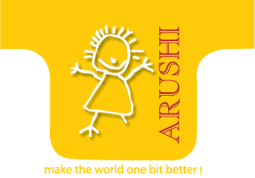**

**Arushi is a Bhopal-based not-for-profit organization working with and for people with disabilities and issues related to them. The basic objective of our work is to generate opportunities and develop capacities in people with disabilities.**

**Vision:** Our Vision is to develop capacities in people with disabilities, working children and others in disabling situations; and to generate opportunities for empowering so that they may make their own choices towards leading a better quality of life.

**Goals:**

* Inculcating self-confidence in persons with disabilities (PWDs) through awareness- building, education and training.
* Linking PWDs with various developmental schemes.
* Creating a forum to express their concerns and advocate their rights.
* Disseminating information on various aspects of rehabilitation.
* Developing a cadre of trained professionals to work with PWDs for their integration into the mainstream.
* Creating awareness in the society to foster a positive attitude towards PWDs.
* Developing instructional material for students with visual impairment on alternative formats such as audio, Braille and digital talking books.
* Undertaking research-based activities to complement its objectives.

**Contacts:**

**Address:- No. 1, Shivaji Nagar, Near MPEB Office, Bhopal(M.P.)**

**Email:- arushiorg@gmail.com**

**Phone:- +91 755-2550827**

**Helpline On Disability:- 1800-233-4397**

**Website:- arushi-india.org**

**3. Aryakar Vigyashree Mathshree**

**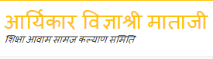**

Vigya Shree Shiksha Avam Samaj Kalyan Samiti, Bhopal is a secular charitable, non government, non profit voluntary organization, working in the field of education and public welfare in the backward district of its area operation.

Society operation covers watershed Management, Agriculture training & extension, environment protection & enrichment. Health education & medical facilities, care for aged rehabilitation of orphans/ destitute/ handicapped/ street/ and poor children literacy and propagation of science & scientific tamper in common man’s life.

This organisation is providing technical computer education to the youth to cuts the unemployment problem from the society. In this respect the organisation is planning to establish training programme in rural areas along with urban cities work for the upliftment of labour child is at priority.

Mission

The organisation has the motto of changing the world through education on order to bring about positive change in the society.

**Website :** [**https://www.vigyashree.com**](https://www.vigyashree.com)

**4.WaterAid**

**C:\Users\dc\Desktop\wateraid-logo.jpg**

**Our mission is to transform the lives of the poorest and most marginalised people by improving access to safe water, sanitation and hygiene**

**Our impact**

**Our programs serve a wide range of communities, from those living in remote rural villages to small towns to slums in major cities including New Delhi, Hyderabad and Bhopal**

E-7/698 Arera Colony, Bhopal – 462016, Madhya Pradesh, India.   
  
Tel: +91 755 4222482 / +91 755 4222582   
Fax: +91 755 4222482

WEBSITE : http://wateraidindia.in  
Email: [wairow@wateraid.org](mailto:wairow@wateraid.org)

**5. Arogya**



Arogya is a voluntary organisation working for social, political and economic development in Centeral India . Established in 1995, Arogya, as its name suggests, is distinguished primarily by its evolving orientation. It has taken up many kinds of issues and taken up many kinds of issues and undertaken a variety of projects with several, sometimes divergent approaches.  
  
The unity that underlines this diversity has been provided by Arogya' pro-people and pro-empowerment orientation, continuous effort to respond to people's voices and changing circumstances, and the priority given to concrete experience over conceived theory or received dogma. Over its more than two decades, Arogya has been characterised by creative efforts and experimental, open-ended attitudes. Diverse adventures and turbulent events, therefore, have filled these years.

Contact Us  
  
  
Arogya Jankalyan Sanstha,  
6 th Floor,Platinum Plaza,  
Near Mata Mandir,  
Bhopal(M.P.)462003.  
Mob:-09826013150,TeleFax:-0755-4236150  
Email:-info@arogya.name

Website : <http://arogya.name>

**6. RDSS – SILWANI**



RDSS stands with a vision to assist the rural communities to sustain themselves, and improve their socio-economic status by providing quality education, medical care, skill development and improving livelihoods. In the process of development, priority is given for Tribal leadership and attempt is made to bring the tribal population into the

**Our History:**   
Education of the Children was the first activity started. Later it was intensified with Boarding houses which take care of character formation of children and quality education and leadership training. After the registration of the Institution, an integrated approach was adapted with three major sectors of development: health care services, quality education, and agriculture cum natural resource management. Presently, there are 4 branches where Boarding houses were established for quality education and rural masses are assisted in 140 remote villages for socio-economic development. It is a joint venture of the diocese of Sagar and CMI St. Paul Province Bhopal.

Contact -RDSS (Rural Development Service Society),

Silwan, Post Silwani,

Tehsil Silwani,

Raisen District,

M.P. 464886,

INDIA

Website : <http://rdsssilwani.org/rdss/>

**7. NAMAN SEVA SAMITI**

****

Started in 1999 and registered under Madhya Pradesh State Society Registration Act 1973, Naman Seva Samiti has successfully transformed marginalized communities in Madhya Pradesh to be independent and self-reliant. Working with communities for more than a decade now, Naman Seva Samiti mission is collaborative and sustainable community development. Naman Seva Samiti is focusing on inclusion of poor and marginalised communities. While a cooperative credit and savings bank, a spice processing and packaging unit and organic farms are the tangible resources, a more enduring outcome has been the number of poorest of the poor who have now experienced pleasure and dignity through these set ups

Naman Seva Samiti  
Vikas Nagar, Athner  
District Betul  
Madhya Pradesh - 460110 India  
 +91 (7144) 286589

[info@ngonaman.org](http://ngonaman.org/contactus.html)

[www.facebook.com/namansevasamiti](http://ngonaman.org/contactus.html)

website : <http://ngonaman.org/>

8. SANIDHYA



|  |
| --- |
| mission  To work for women and child development & fight against HIV AIDS. Especially work to make all females independent so that they can live life with a dignity and freedom. |
| Vision  Healthy World without poverty and injustice, in which every woman, man, girl and boy enjoys the right to live life with dignity.  Contact  Sanidhya HIG 112, Rivera Township, Near Mata Mandir, Bhopal (M.P.) India   Telephone : +91 755 4900884 Mobile : +91 7879224744 , 9893126606 Email: [sanidhya30@gmail.com](mailto:sanidhya30@gmail.com)  Website : <http://sanidhya.org/>  **9 .SAHYOGMITRA**  **C:\Users\dc\Desktop\SAHYOG LOGO (2).png**  **SAHYOGMITRA WELFARE SOCIETY is a national level non-political, non-religious, non - government organization registered under Madhya Pradesh Society Registeration Act 1973.**  **We are registered to function on all India basis. Our prime goal is to provide a better and a happier life for all. We run many campaigns and activities across India to improve the quality for the people.**  **Our Mission -**  **Our mission is to work on the grassroots level to enable the society across the country to engage proactively in the change process  and adopting the highest standard of society and thereby emerging as a leading knowledge and technology driven , innovation and scalable national development organization from India**  **CONTACT**  **WEBSITE :** [**https://sahyogmitra.webs.com/**](https://sahyogmitra.webs.com/)  **10. Samuadayik Vikas Parishad**  **C:\Users\dc\Desktop\tewa_logo.gif**  Samuadayik Vikas Parishad is a registered society committed for social service. The foundation of the society rests with senior people who have been included in the society, right from the inception of society. The society is contributing for the social cause of restructuring the social activities of the state of Madhya Pradesh.  In this modern world of science and technology the development of any country primarily depends on the contribution of its Human Resource specially in the field of technology. Madhya Pradesh has a special status in our country from the view of population and resources. People associated with the field of science and technologies are contributing for the development  **Contact :**  **Add: MIG 8/8 Gitanjali Complex, T. T. Nagar, Bhopal(M.P.)India Email Id:**[**mukeshlalji@rediffmail.com**](mailto:mukeshlalji@rediffmail.com)**,**[**mukeshlalji10@yahoo.com**](mailto:mukeshlalji10@yahoo.com)**,**[**mukeshlalji10@yahoo.com**](mailto:mukeshlalji10@yahoo.com) **Mob. No.: +91-9826078205**  **WEBSITE :** [**http://tewasamudayik.org/**](http://tewasamudayik.org/)  **11. Rising Aryavarta Welfare Society**  **C:\Users\dc\Desktop\LogoColorNoText-Copy1.jpeg**  Vision -To transform underdeveloped and developing society into developed form.  Mission -To create a culture of Safety and Resilience. -To develop an environment of Humanity. -To create a culture of Safety, Health and Eco friendly Environment. -To build up a persona of responsible citizen amongst Indians. -To empower people and communities in situations of illiteracy, poverty and disease. -To achieve large scale positive changes through economic and social programmes that enable men and women to realise their potential. -To develop network with government, private, NGOs and national and International Institutions  **CONATCT :**  **27-9A, Saket Nagar Bhopal-462024, Madhya Pradesh (India)**  **WEBSITE :** [**http://rawsindia.org/**](http://rawsindia.org/)  **12. Active Blood Donors**    Every three seconds someone needs blood transfusion in India because of higher Road Traffic Accidents rates, premature babies, major surgeries and medical emergencies requires Whole blood, where many of the seekers suffer because of blood unavailability at mean time, because Blood Seekers ratio is much higher as compare to the available Blood donor’s data and information maintained. Our Primary aim is to spread public awareness about voluntary blood donation to dissolve the myths to improve voluntary blood donation ratio, and for that we start our mission “Awareness on Blood Donation” through by our portal Active Blood Donors as “SHIPRA” based on the concept of “On-Call-Blood Donor Availability System” that means Blood Donor’s availability directly to the recipient in emergencies by call, especially for Madhya Pradesh and Chattisgarh.  **Contact:**  Active Blood Donors  Email: [contact@activeblooddonors.org](mailto:contact@activeblooddonors.org)  Mobile: 9202224006  WEBSITE : <http://activeblooddonors.org/> |

13. DISHA

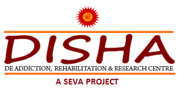

SRIDISHA is the region's leading NGO working for providing comprehensive health care services for prevention, treatment and rehabilitation of persons having Alcohol and drug addiction problems.

We beleive in CURING addiction and finding a permanent solution for the problem.

We believe in providing services of the highest quality and in achieving superior levels of patient satisfaction through the combined efforts of our outstanding team.

It is all part of our service-oriented mission

Contact

14-M Shastri Nagar, Depot Square, Jawahar Chowk, Bhopal, Madhya Pradesh

**Phone :** +91 98930 30901, +91 98930 30931, 0755 6457129

**E-mail :** sanjay1shrivastava@gmail.com

WEBSITE : <http://www.sridisha.com/>

**14. SWARGIYA SUSHILA DEVI SEVA SAMITI**

****

SSDSS is the objective of Skill Development is to create a workforce which is empowered with the necessary and continuously upgraded knowledge w.r.t. their implementation and Health and Education ,Poverty & Social Justice ,Training Programmes and self dependency ,Youth Empowerment, Women’s Empowerment website.

It aims to increase the productivity and employability of workforce (including wage and self-employed) both in the organized and the unorganized sectors. It seeks to increase participation of youth, women, disabled and other disadvantaged sections and to synergize efforts of various sectors as well as reform to enhanced capability in order to adapt, to changing technologies and labour according to the market demands.

Please call Us at :   
Tel: 0755-4254788  
Mob:+9181036271547,+918236852578.

Email Us : [ssdsevasamiti96@gmail.com](mailto:ssdsevasamiti96@gmail.com)

**WEBSITE :** [**http://ssdsevasamiti.org/**](http://ssdsevasamiti.org/)

**15. Swami Ambrish Chetanya Sewa Samiti, (SACSS)**

**C:\Users\dc\Desktop\logo\logo1.png**

Swami Ambrish Chetanya Sewa Samiti, (SACSS) was formed in the year 2011, 8th November by a group of socially conscious people as a new pedagogical landmark in the realm of Indian vocational training. Today, it stands tall as one of India’s largest vocational centers with updated training methodologies and effective course modules. Furthermore, it plays a pivotal role in building sustainable industry-ready quality capacity across urban, suburban, rural, underdeveloped and hill areas not only of India. We facilitate development of corporate workforce across all cadres.

By offering tailor made training programs in both English and Hindi & reliable performance measurement we add value & growth to our clients business.

SACSS, an NSDC partnered has expansive presence, made-to-order training prospect and curriculum proficiency to cater to IT and non IT sectors as well as the sectors of Electronics, Travel & Tourism, Retail, Hospitality, Agriculture, and Healthcare, Manufacturing and Designing and more. Education, Telecom, Apparel, Automobile, Health, Engineering, Rural Development, Industry and Commerce and more.

**CONTACTS**

**Swami Ambrish Chetanya Seva Samiti vaishali vihar road, near sagar puliya, sagar road**

**Vidisha Madhya Pradesh 464001  ,**

**Mobile Number : 9755550416,9755550039**

**WEBSITE :** [**http://swamiambrish.org/**](http://swamiambrish.org/)

**16. SAMARTHAN**

****

**Vision**

**Every citizen contributes meaningfully in shaping democratic State and enjoys benefits based on the principles of equality and equity.**

**Mission**

**Promote and support participatory governance for equity and inclusion in development processes by capacity building, generating evidences and advocating the perspective of the most marginalized for enriched democracy.**

**CONTACT US**

**36, Green Avenue, Chuna Bhatti, Kolar Road**

**Bhopal, Madhya Pradesh, India**

**Pin Code: 462016.**

**Tel: +91-755-2467625**

**Mobile: +91-9893563713**

**Fax: +91-755-2468663**

**Email:**[**info@samarthan.org**](mailto:info@samarthan.org)

**WEBSITE :** [**http://samarthan.info/**](http://samarthan.info/)

**17. VIKALP SANSTHAN**

**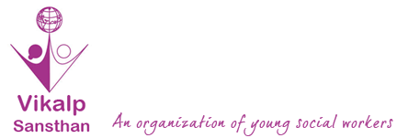**

Vision  
To create a violence-free society based on equity, peace and justice, where all people enjoy

* Physical and mental freedom for all
* Freedom from gender violence
* Equal opportunity
* Freedom from discrimination

Mission  
To empower youth to end gender-based violence and discrimination through creating alternative and creative ways for them to voice their opinions, integrating them in the process of social development and creating a future which is just and equal for all.

**CONTACT**

**WEBSITE :** [**http://vikalpindia.org/**](http://vikalpindia.org/)

**18. MADHYA PRADESH VIkLANG SAHAYATA SANSTHAN**

**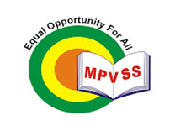**

MPVSS, started in 1997, is an NGO working towards provision of education, therapeutic welfare, vocational training and other necessary services to persons with disabilities for the last 17 years in the districts of Ujjain, Shajapur, Rajgarh and Agar in the state of Madhya Pradesh

MISSION

* To create a conducive atmosphere for their holistic development and mainstreaming them with the society.
* The Samiti has been providing different types of services to several hundreds of children and adults with intellectual and developmental disabilities and also other disabilities through its various programs. At the same time Samiti has been making continuous efforts to sensitize the society towards persons with disabilities which is showing positive results now in the areas where it is working.

VISSION

To create an inclusive society in which persons with disabilities will enjoy equal rights, opportunities and participation.

CONATCT

Manovikas Special School, Sector-9 , Jawahar Nagar , Nanakheda , Ujjain (M.P)-456010

**Phone :** 0734 – 2511031 , 2513502, 4061910

**Email:**[mpvss10@gmail.com](http://mpvss.in/contact-us/), [contactus@mpvss.in](http://mpvss.in/contact-us/)

  WEBSITE : <http://mpvss.in/>

19. HUMAN WELFARE SOCIETY

C:\Users\dc\Desktop\logo\logo-2.png

Human Welfare Society(HWS) is a non-Government organization established by the devoted social workers in the year 1987 with a noble mission to undertake actions for the Welfare of the Society. Our Society is working from 30 years on the objectives of Social Services. Today HWS is functioning on 14 objectives pointed towards common goal of improving the quality of life by organizing multiples Welfare programmes. We follow a need based and response oriented programme planning and management approach to ensure the better implementation of its programmes.

**Vision:**

To create a society where there is a prosperity and peace with better quality of living. Human Welfare Society has put in place a path-breaking action plan to create educational, health and housing facilities to improve the lot of millions of poor people in the country under Human Welfare Foundation as “Vision 2016-17”.

**Mission:**

To promote the socio economic development by imparting multidisciplinary programmes particularly to the vulnerable section of the community. Our Mission is to help the needy peoples and the surrounding areas with the economy by raising funds to help families in foreclosure, and in essence help lift people back onto its feet.

CONTACT

**15, Ghatkarpar Marg, A.P.M. Chamber,**

**Freeganj, Ujjain (M.P)**

**Ph No. : 0734 – 4218777**

**Mob No. : +91 9926393777**

**Email :**[**humanwelfareujjain@gmail.com**](http://humanwelfareindia.com/contact-us/)

WEBSITE : <http://humanwelfareindia.com/>

20. **SONALI PUBLIC SHIKSHA SAMITI**

****

**The essence of our effort is to see that every child has an equal opportunity, not to become equal, but to become different to realize whatever unique potential of body, mind and spirit he or she possesses !**

**WEBSITE :** [**http://spsguna.com/**](http://spsguna.com/)

21. CENTER FOR INTREGATED DEVELOPMENT

C:\Users\dc\Desktop\logo\logo.png

CID from its inception is standing with its core value, commitment towards weaker sections of the society especially children, women, tribal and Dalits in particular and deprived section of the society in general. During its long journey, CID had achieved a place of reputed and responsible organization in the region particularly on the issues of child rights, women rights and empowerment, tribal rights (Sahariya Tribal) through its consistent efforts on key aspects affecting their lives. CID efforts and achievements on Sahariya tribal rights through it programme Freedom from Hunger and Fear is recognized by various segment of the society.

       CID is well recognized for its work on protection of child rights through its continuous efforts made on Child labour Eradication, Education, Health, Nutrition Support and children & community groups to defend child rights along with emergency response to children in distress need of care & protection.

     CID has been directing its efforts to address other issues apprehension to community like Health, Sanitation and Environment, HIV/AIDS protection, BCC for child health and survival, village planning, female infanticide and violence against women. With sole objective of organizing & empowering community to achieve their legitimate rights, community organization had been developed and empowered through training and capacity building programmes and building alliances at Local, Regional, State & National level. SAJAG (Sahariya Jan Gath Bandhan) & other community based organizations have played an important role to bring changes at different levels. In our journey of goal realization, CID has been supported by like minded people, organizations & community based structure. CID set targets and strive to achieve them through consistence efforts by implementing our programmes with committed team and volunteers.

          Last but not least, we are extremely grateful to our Partners such as TDH Geneva and Germany, ACTION AID INDIA, UNICEF, ILP, MPSACS, CHILDLINE India Foundation, NCLP, MPVHA and CID Board members for their constant guidance and support in determining our contribution and efforts meaningful.

WEBSITE : <http://www.cidindia.org/>

22. Ehsaas

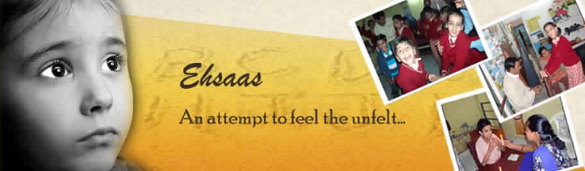

Ehsaas is a non-profitable society run in Gwalior for special children with cerebral palsy, autism and slow learning types of disabilities. For knowing more about us, know our family....

**Contacts**  
E-mail us at ehsaasgwalior@gmail.com

ring us at 00-91-9229273111 or 00-91-751-2430737 

**Visit Us-**  
Training Center:  
16 Vikas Nagar  
Near Sai Baba Mandir  
Gwalior, M.P., India  
  
Regd. Office:  
108, Pan-in-Plaza,  
Shinde ki Chhawni,  
Gwalior, M.P., India

WEBSITE : <http://ehsaasindia.org/>

23. FAMILY PLANNING ASSOCIATION OF INDIA



MISSION

To advocate for gender equality and empowerment for all including the poor and vulnerable people, ensure information, education, and services; powered by knowledge, innovation, and technology, towards sustainable development.

VISSION

FPA India envisions all people empowered to enjoy their sexual and reproductive health choices and rights in India, free from stigma and discrimination.

WEBSITE : <https://fpaindia.org/>

24. AADHAR FOUNDATION



**Movement for Rights & Entitlements of Women, Child & Differently Abled**  
 **"Rehabilitation and Development Center for Disabled Children"**  
**“Community Based Rehabilitation Services”**  
**“Special Education and Training Services ”**  
 **“Counseling,  Guidance  and  Advocacy  Services”**  
 **“Early Identification & Intervention Services”**  
 **“Pre-Vocational & Vocational Training Services”**  
  
  For   Special  Children  /  Persons  with  Disabilities  as  Mentally / Intellectually Challenged, Down Syndrome, Cerebral  Palsy, Autistic,  Hyper Active, Learning  Impaired / Slow   Learner,  Speech, Language &   Hearing Impaired, Deaf-Dumb, Visually Impaired, Blind, Physically Challenged, Multiple Disabled & Mentally

CONTACT

Opp. Ayush Dhaba, Near Iqra Convent School, Parasia Road,  Poama,   
Teh. & Distt. Chhindwara (MP) –  480001

WEBSITE : AADHARFOUNDATION.WEEBLY.COM

25. Social Engineering and Welfare Action Trust



Social Engineering and Welfare Action Trust was established on 12th of December, 2007 by a group of scholar, activist and social scientist. The aim was to develop social engineers who can change the nation in a positive direction. The trust is committed to work for sustainable and allround development of marginalized and socially deprived population. It works directly with the helps of trained social engineers at the grassroots, in a spirit of enably communities to build upon their skills, initiatives, resources and entitlements rather than delivering services or solutions to them.

We are committed to actively work for the Gram Swaraj to achieve sustainable development of the less privileged and marginalized sections of the community through appropriate strategies in primary educations, community organization, income generation, health, hygiene, rural micro-credit and empowerment activities. We believe in espousing and supporting all such causes that help the marginalized and deprived people.

CONTACT

**Social Engineering and Welfare Action Trust**  
**Luxman Vihar Colony, Kamta,  
Chitrakoot Distt. Satna M.P.- Pincode-485336**  
**Phone no.**: 07670-265603    
**Mobile no.**: 09424356841  
**Email**: [sewatrust123@gmail.com](mailto:sewatrust123@gmail.com)

**Website :** [**http://sewatrust.org.in/**](http://sewatrust.org.in/)

**26. MOLECULAR WELFARE SOCIETY**

**C:\Users\dc\Desktop\logo\logo.jpg**

|  |  |
| --- | --- |
| |  | | --- | | **Molecular Welfare Society** is a Non-profitable, Non-political and Non-Governmental organization established by a group of committed social workers and volunteers in 1996 under M.P. Society Registration Act **1973**(sub para 44). Molecular continues making efforts for the betterment of marginalized, deprived, | |
| ignored section of society by giving them a platform through it creative. Program and activities. It believe in the dignity of people and developing their capacity to over come their problems. |
|  |
| **Molecular Welfare Society** works in Gwalior, Indore, Reewa, Dewas, Sheopur, Shivpuri Districts in Madhya Pradesh State |

WEBSITE : <http://www.molecularwelfaresociety.org.in/>

27. SAMBHAV SOCIAL SERVICE ORGANIZATION

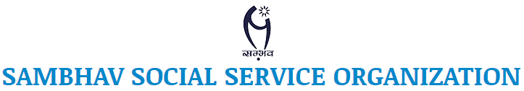

Sambhav Social Service Organization is a voluntary agency working in the areas of rural and    urban development, child education and   women empowerment through advocacy, direct program interventions and capacity building of the community to access the benefits of the State Programs. It has been actively involved in the organizing Sahariya Tribal communities to assert their rights of equality, Health, food and secured livelihood and a respectful place in the society.

Goal:

“Equality, Opportunity and Justice for All”

 Mission Statement:

"Building equitable, democratic and environmentally sustainable society."

Vision:

"Striving for sustainable development processes and improvement in the quality of life of vulnerable people like Tribal, women and children through their organization and capacity building efforts.”

WEBSITE : <https://www.sambhavindia.org/>

28. Shabri Samaj Sewa Samiti



Shabri Samaj Sewa Samiti is the official Social Service Organization for the Madhya Pradesh and is registered under the Societies Registration Act 1962 of (Reg. No. 4015). Reg. Date- 16-10-1996 It is a non-profit, registered, charitable society in Madhya Pradesh. the organization consist the group of committed social workers, Management Experts, Professors, Trainers HRD professional and Retd. Govt. Officials and Entrepreneurs and other well-meaning citizens, who have pledged to help, develop support and facilitate the Urban and rural community in the area of Poverty eradication and Livelihood development, Education, Health, Agriculture, Environment, Youth Development and Social Reform through various activities and practices in several districts of Madhya Pradesh. The organization is receiving funds from the states and central government and other funding agencies for its rural / tribal poverty reduction, training programmes, women empowerment programmes etc.

CONTACT

**Address:**C/o Mahesh Chandra Gupta  
Gohdi Gate, Gohad,  
District- Bhind M.P  
**Contact No:**7828393585,  
**Email ID:**ssssamitibhind@gmail.com

WEBSITE : <http://ssssamitibhind.org/>

29. **SAKGVS**

**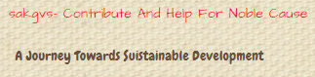**

**The mission & vision of the SAKGVS to create awareness in every aspect and provides basic education, food and employment through entrepreneurship for every common men in the society.**

**WEBSITE : https://www.sakgvs.org/**

**30. ASRA**

**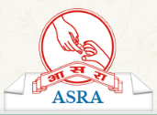**

**ASRA aims to provide people from the world over the opportunity to work in evaluated and credible NGOs in India. Programs are selected that best match the skills, area of interest, expertise, and time availability of the individual, with a view to strengthen and add value to the ongoing work of in India’s social development sector. Joining Hands’ vision is to influence positive social change**

**Our Vision**

**" To empower the communities towards sustaining the development process leading to their total well being "**

**Our Mission**

**" To foster integrated community development program through multi preventive & corrective programs and peoples participation "**

CONTACT

EMAIL : info@ asrango.org

WEBSITE : <http://asrango.org/>

31. JAN SAHAS

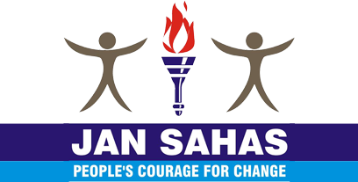

**Jan Sahas** is committed to promote the development and protect the rights of socially excluded communities with the special focus on girls and women through eradication of all forms of bondage including manual scavenging and caste based prostitution; empowerment of adolescent girls and women to end violence and gender justice, skill development for dignified livelihoods and social entrepreneurship; legal aid for access to justice and reform in criminal justice system; support in education; food and nutrition security; land and agriculture development; develop barefoot lawyers to build victim or survivors as leader and empowerment of communities though capacity and organization building.

EMAIL : [jansahas@gmail.com](mailto:jansahas@gmail.com)

WEBSITE : <https://jansahasindia.org/>

32. PLAY INDIA PLAY

C:\Users\dc\Desktop\logo\pip_logo.png

**Missions of Play India Play:**

**1. To introduce "Right to Play"in the constitution of India as one of the fundamental rights.**

**2.Endeavour to ensure that each and every citizen of India gets the opportunity to play for wholesome (all round) development. Especially, no Child is denied the opportunity to play.**

**3.Advocating for legal and policy reform in line with the principles and standards of the Right to Play and other relevant international and regional instruments.**

**4. Implement article 31 of United Nation Organization (U.N.O.) in India.**

**5. To provide platform for 'Play' to all across socio-economic, cultural, sex, color and religion segments of India especially for children.**

**6. To improve the understanding of importance of play to improve the quality of life.**

**7. Improving the understanding regarding the play (physical activity) & its inherent benefits to human race.**

WEBSITE : <http://playindiaplay.org/>

33. Uday Bhav Scoiety for Women Empowerment

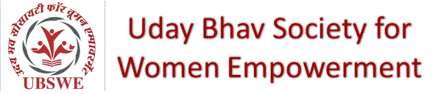

UBSWE (Uday Bhav Scoiety for Women Empowerment) is an organization working on women empowerment with a holistic approach which includes the necessary activities required from creating awareness to the practice of gained awareness in a life of woman.

We partner with local projects in and aorund Gwalior city that primarily support women and girls, acting as a platform to end lack of awarness in daily and normal life routines and obviously in education. We are trying to improve wellbeing across families and communities. In practice, this means helping school children, health workers and others in need to get the training and skills required to raise themselves, their families and their communities out of poverty and helplessness for good. Our project's focus is on women and children education, health and self-employment, but we are trying to grow big so that we can offer assistance to anyone regardless of race, or religion.

WEBSITE : <http://www.ubswe.org/>

34. SUMAN SHIKSHA VEVAM SAMAJ KALYAN SAMITI

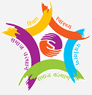

Organization which concluded “effort” is a non-profitable, Non-governmental organization established by a group of committed social workers and volunteers and professionals in 1989 under section Madhya Pradesh Society Registrikaran Adhiniyam 1973 wide sub para 44. organization making efforts for the betterment of marginalized, deprived, vulnerable ignored section of society by giving them a platform thorough its creative Programs and activities. It believes in the dignity of people and developing their capacity to overcome their problems.

WEBSITE : <http://ssysks.org/>

35. **Bhagyashri  Seva  Sansthan Rupauli**

**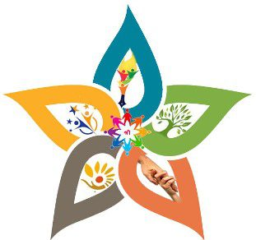**

Bhagyashri  Seva  Sansthan Rupauli  is a registered NGO that currently operates in the state of Madhya Pradesh, with the Head Office in Rewa MadhyaPradesh, we have several branch offices in MadhyaPradesh State. As our aim suggests,  we consider it a privilege to be able to do “ Siksha ,Sewa,Sahyog ,Jankalyan and Utthan ”, to serve our fellow human –beings with the utmost dedication and compassion. We believe that every life has equal value and an equal right to live with dignity. We have been, and are currently working on many different projects, viz.. – HIV-AIDS (TI); Financial Literacy; JLG & SHG formation; Skill Development; Training & Consultancy; Education , Anti Tobacco Program, TB control, Water & Sanitation etc

Contact

bhagyashrisewasansthan@gmail.com

WEBSITE : <https://bhagyashrisevasansthan.wordpress.com/>

36. DAYS SOCIETY



The Society is a social organization driven by human religion, Society, Water, Environment, Agriculture, Rural Development, Child Protection, Women's Empowerment, Beti Bachao Beti Padhao, Health, Art Culture, self-employment training and social work.

WEBSITE : <http://dayssociety.com/>

37. SHRI KRISNA GRAMOUTHAN SAMITIC:\Users\dc\Desktop\logo\skgs.jpg

**Vision**  
To create opportunities for the marginalized and the under privileged groups for their socio-economic development to mainstreams without discrimination of cast, creed, language, race and religion. & to take part in developmental processties.  
  
  
**Mission**  
Through building local level institutions, capacities of poor and needy youth, women, dalits, tribes and small and marginal farmers with special reference to Education, health & natural resource management.

WEBSITE : <http://skgsmpindia.org/>

38. **Jan Sansadhan Vikas Avom Jeev Kalyan Samiti**

**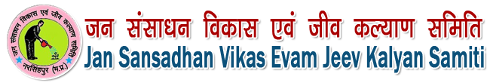**

"Jan Sansadhan Vikas Avom Jeev Kalyan Samiti" is a registered social Organization. It is registered with the Asistant registrar of firms and society, Jabalpur (MP) zone under the “ Madhya Pradesh Society Registrikaran Adhiniyam 1973 ( Serial 44 of 1973) dated 17th April 2008 under registration number 04/16/01/10298/08.

As on August 15, 2018 we have registered more than 44 Thousand volunteers with our project. We are working on our “Swarnim Bharat Nirman Project” for last 10 or more years and have prepared the model to get results according to our vision. Now the project is to be launched shortly Nation Wide.

The Vision of organization

To build our great country  India “BHARAT” more and most prospers, Capable in all aspects, having planned projects for the solution of major problems just like the unemployment, poverty, illiteracy, Health Problems, addiction, water conservation, plantation, Population control, dowry etc.

We have submitted 50 aims with the registrar to cover up the maximum public problems.  We have registered our working area as all India.

Our Mission

To collaborate with the undeveloped / unemployed or needy / interested people and motivate / support them to bring in main stream as per their academic qualification / Experiences for specific field as well as their financial situation. We provide them a unique platform of professional social workers to assist financially / morally, issuing the grants from organizational system (This system is a unique combination of Social activities, Business, Media and political development through social networking) for education, medical, business and other essential requirements as per the project’s rules and regulations in accordance of Social activities done by them.

**WEBSITE :** [**http://jsvjks.com/**](http://jsvjks.com/)

**39. Pratyaya EduResearch Lab**

**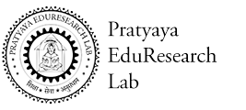**

Pratyaya EduResearch Lab is a not-for-profit organization (registered as a Section 25 of the companies Act, 1956), established in 2014 with a vision to contribute to society that facilitates a meaningful, innovative and high quality education affordable and reachable to all. We are based in Pandhurna , a small town of Chhindawara District, Madhya Pradesh. Our approach has been to focus all our resource, effort and research on systemic improvement in quality of education in rural areas such that it will empower marginalized community and help to build an equitable and sustainable Society.

WEBSITE : <http://pratyayaeduresearchlab.org/>

40. KRISHAK SAHYOG SANSTHAN



**Vision:**

Management of natural resources in perpetuity and establishment of an independent, equitable and just society beyond the caste,  religion, race and gender.

**Mission:**

To enable the capacity of the last  individual of the society – scheduled caste, scheduled tribes, marginalized farmers and rural women to determine their own development direction and prudent management of resources.

CONTACT

**Address:**15/373 , PHE Road , Near Reliance Office  
Arjun Nagar , Raisen , District – Raisen (MP).

Pin Code – 464551.

**Phone No.:**09826036283.

**Email ID:** contact@kssraisen.org

WEBSITE : <http://www.kssraisen.org>

41. **AZAD VIKALANG KALYAN SAMITI**

****

**AZAD VIKALANG KALYAN SAMITI** (AVKS) came in to existence to safe guard and welfare of the disabled people. It is formed by group of disabled persons, for the disabled persons and to be with the disabled community. **AVKS**is a non-profitable, non-political, non-religious voluntary organization, registered under Madhya Pradesh Society Registration Act, 1973 since 2009 serving persons with disabilities, vulnerable families from most backward areas of Jhabua and Alirajpur districts of Madhya Pradesh. It is also registered under Section 51 & 52 of the Persons with Disabilities (Equal Opportunities, Protections of Rights and Full Participation) Act, 1995 initiated by Department of Social Welfare, Govt. of NCT of Delhi.

AVKS is striving to build hope among the disabled people through developing opportunity of livelihood sources, awareness of social issue, health services, rehabilitation, promotion of education and vocational courses. We focus to establish a participatory and integrated approach to mainstream disable people towards dignified, self sustained and quality life.

**Vision**

Envision a society wherein equality and justice are extended to every person with disabilities and avail life with dignity and immense opportunity for prosperity.

**Mission**

* To eradicate the stigma of "vikalang" from the society through community participatory approach and social awareness.
* To create opportunities for persons with disabilities to enable them to be self- reliant, confident and have a dignified life.

WEBSITE : <http://avksjhabua.org/>

42. EDUCATIONAL RURAL WELFARE SOCIETY

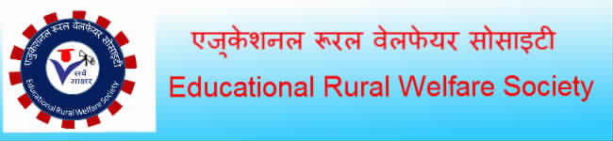

ERWS endeavours to reach out & assist the poorest of poor through various health & development programmes based upon the community needs & available manpower

ERWS is to empower underprivileged children and youth through relevant education and market-focused livelihood programmes. Smile to deploy best possible methodology and technology for achieving ideal SROI (social return on investment), to practice and promote good governance. To link business competitiveness of the corporate with social development initiatives, also to sensitize privileged children, youth and citizens in general to promote Civic Driven Change.

WEBSITE : <http://erws.in/>

43. MAWE 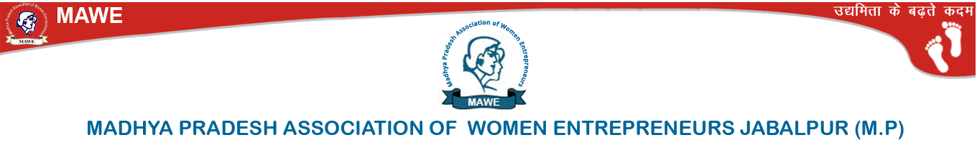

Madhya Pradesh Association of Women Entrepreneurs (MAWE) a front-runner in the field of NGO’s run by Women Entrepreneurs was founded on 8th March 2000 (previously as Mahakaushal Association of Women Entrepreneurs). It is registered under the Madhya-Pradesh Firm’s Society Registration Act 1973. It was observed that Central India was totally devoid of any active platform for encouraging and establishing women entrepreneurs. However women in large numbers were employed in income generating activities in an unorganized sector, which was impeding their development

MAWE aims to provide access to Information, Finance, Technology & Marketing in a more comprehensive manner. Trainings being an integral part of the programmes. This will enable the Empowerment of Women through Economic independence.

WEBSITE : <http://maweindia.com/>

44. Shri Hittantra Nyas

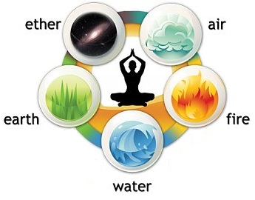

**Shri HitTantra Nyas** is a registered SEWA organization having its head office in ShriVrindavan – The Holy Abode of Divine Bliss. ShriVrindavan is such a place of Radha-Krishna where idealest Couple Consciousness is continuously sporting delightfully and which is indeed a real basis of natural combination of Positive and Negative Energies. In the adored concerns of ShriVrindavan **“Forest Splendor”** has achieved a supernatural respect as a couple – sport – stadium. This positive and negative couple – energy is the directing authority of cosmic activities

WEBSITE : <http://shrihitsadhana.org/>

45. SIMBOSIS

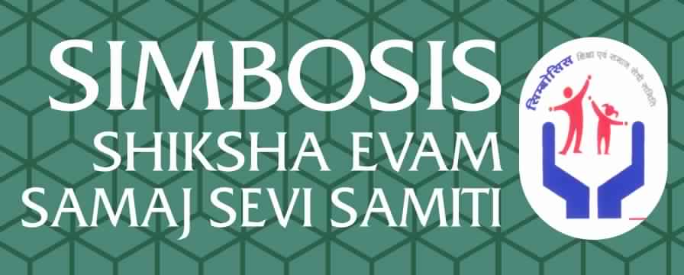

* Our Vision

“There is enough for everyone’s need but not for everyone’s greed.””Mahatma Gandhi”

* Our  Mission

To become the center of excellence & knowledge in field of women’s Rights and child development.

* Our Founders

We are very thank full  to our founders and their supports.

WEBSITE : <http://simbosis.org/>

46. UDAAN



Resolving the problem of student.

To disseminate the organization.

Cultural program

Plantation

Providing copy books to poor Vidhyarthias.

Making an inspection committee in the Vidyalaya College.

Increasing the level of education.

To disseminate the promotion of education, this is to establish and manage the Vidyalayas and Colleges of rural and urban areas of entire India.

WEBSITE : <http://udaansamiti.org/>

47. Comptech Education Society



Comptech Education Society is a public charitable society, deed executed under the societies registration Act.  
  
Comptech Education Society has been formed with an objective for public and charitable purpose and its income shall also be wholly for the public and charitable purpose without prejudice and discrimination on the basis of cast, language or religion. Join with our team to empower the society.

WEBSITE : <https://comptechmp.weebly.com/>

48. DAKSH FOUNDATION



**Daksh Foundation** is a non- government organization whose mission is to illuminate women and children seeking life in order to enhance livelihood with proper direction in the field of education, health, child care, women empowerment.

**Daksh Foundation**is an innovative organization created to develop skills among the backward & illiterate community in India & work for the cause of women empowerment & development. As one of the pioneer non-governmental organizations in the country, Daksh Foundation focuses on high-quality, low-cost, and replicable interventions to address gaps in the skill upgradation plans. Established in 2007 to provide skill development & women empowerment, Daksh Foundation has grown both in scope and geographical coverage.

WEBSITE : <http://dakshfoundation.org/>

49. MISSING INDIAN KIDS



**N**ational Centre For Missing Children (NCMC) is a non political, non profit making and a non-governmental organization offering the services free of charge.  
  
**T**he site is presented for the parents, guardians, law enforcement agencies, free of charge, on a one to one manner as an alternative and unconventional method for locating a missing child who is lost or is suspected of having been kidnapped or is a runaway. It serves as a complement for the conventional methods and is not intended to interfere with the system's procedures or to promote false hope.

WEBSITE : <http://missingindiankids.com/>

50. BAL NIKETAN SANGH INDORE



Since 1947, Bal Niketan Sangh has been committed to providing quality education and holistic development of students. Based in Indore, Madhya Pradesh, our school serves and caters to all social and economic strata of society. We are a strong community of students, parents, teachers and staff, united by a common aim to make education affordable and accessible.

MISSION

Bal Niketan Sangh is not only committed to education and well-being of its students, but also an organization involved in social upliftment of children, women and Adivasis. Our mission is to advance the quality of life through holistic education. We believe every student is unique and our goal is to help our students reach their learning potential.

VISSION

* To create a culture of academic excellence, ethics, diversity and social change.
* To increase and improve access to quality education and improve learning outcomes.
* To become a center of excellence in the field of women and child development, and implement activities and projects relevant to their needs.
* To provide meaningful services to the community through the development of ongoing relationships with grassroots community leaders, national and international non-profit organizations and foundations.

**WEBSITE :** [**http://balniketansangh.org/**](http://balniketansangh.org/)

**51. CONCEPT INDIA**

****

Eyeing our growth in all spheres in Madhya Pradesh the CONCEPT Organization was established in the year 2005. Situated priority in Indore and Dewas, the organization dispenses its services in areas in and around Indore. At present the organization is working in 5 villages of Dewas block in Dewas District & 10 villages of Mhow block of Indore division of M.P.

Focusing on an integrated, holistic & participatory approach the organization aims to provide socio- economic and psychological support to the rural people. Owing to changes in the social scenario, the organization is working in full confidence to bring overall development of the deprived. It is working in collaboration with Suzion Foundation Pune, Development Alternatives New Delhi, CASA New Delhi, etc. Organization has registration under Income Tax act 12A.

WEBSITE : <https://www.conceptindiasansthan.org/>

52. INDORE CANCER FOUNDATION



The Indore Cancer Foundation Charitable Trust (ICF) was launched on December 27, 1988, in the presence of Dr. Jatin P. Shah, Professor and Chief, Head and Neck Service, Memorial Sloan-Kettering Cancer Center, New York; Late Mr. Sunil Dutt, former M.P. from Mumbai; Mr. Surendra Wadhwani, Hong Kong; and prominent citizens of Indore.

VISION

To develop a national centre for India’s commonest cancer, the head & neck cancers, and to bring scientific treatment of cancer within the reach of every patient irrespective of socio-economic status.

MISSION

1. To raise public awareness on the importance of early detection & scientific treatment of cancer, even in remote & tribal areas.
2. To facilitate capacity enhancement of the medical cadre, particularly at the rural level, so that they are aware of the preventive aspects of cancer and are adept at its early detection.
3. To improve quality of life of terminally ill cancer patients especially by making them pain free in the end stage of their life
4. Given the high incidence of head and neck cancers in India, develop a national institute devoted to head & neck cancers, a state-of-the-art centre of excellence working on preventive strategies, diagnostic programmes, clinical & basic research, so that we are able to find answers to our own national problem in this area.

WEBSITE : <http://www.indorecancerfoundation.org/>

53. **Meenakshi Mahamaya jan kalyan samiti**

**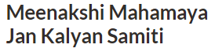**

**Meenakshi Mahamaya jan kalyan samiti (mmjks)was founded in 2002 by smt. Maya singh solanki . mmjks mainly focuses into promotion of Education, Culture, IT and Research & Development in to rural and semi – urban areas of country. Meenakshi mahamaya jan kalyan samiti Credibility:**

**\* Associate of National Skills Development Corporation (NSDC).**

**\* Mmjks is an authorized Vocational Training Provider under the Ministry of Labour and Employment’s Modular Employability Scheme for conducting skills development trainings. \* Authorised to run Madhya pradesh State Govt. approved Vocational Training Courses from Directorate of Vocational Education & Training.**

**\* An authorized Training Agency of Dept. of Employment & Self Employment, Govt. of Maharashtra for imparting trainings on Retail Sales for Scheduled Caste Candidates.**

**\* An authorized Training Agency of District Rural Development Agency (DRDA) under Ministry of Rural Development, Govt. of Maharashtra for imparting trainings on Business Skills Development for rural poor women working in Self Help Groups.**

**WEBSITE :** [**http://www.mmjks.org/**](http://www.mmjks.org/)

**54. SAMADHAN SAMAJ SEWA SANGATHAN**

****

Samadhan Samaj Sewa Sangathan works to enable people facing the Empowerment Awareness and Equality.Our Organization gives them the opportunity to develop their skills and leadership capacity so that they can address the issues affecting their lives. All the body members of the society are fully literate and capable to undertake any type of project to promote the Society and to literate the community about the various segments of the life. In the light of the past experience and having a good knowledge base of the body members and having full sympathy with Employed Rural & Urban Youth of Our Country.Playing the role of catalysts, we help to implement sustainable development processes that will make communities self-sufficient in the long term.We are the team of proffessionals and exeperinced to consultant the people regarding the issue.

Our Vision  
Vision for overall development of the society. Everyone is skilled capable to lives a better life .Our Vision is sustainable development of poor through preservation, conservation and development resources.

Our Mission  
We will give mark able contribution towards skill India by 2020 by providing locally support. Everyone enjoy their life with dignity and prosperity

**WEBSITE :** [**http://samadhan.ind.in/**](http://samadhan.ind.in/)